Safeguarding at The General Assembly Annual Meetings 2024

To help nurture an environment in which all can thrive, The General Assembly employs a safeguarding lead to help enable vulnerable groups, such as children and adults at risk of harm, to feel safe and participate fully at its events. That person is Gavin Howell.

In preparation for this event, the safeguarding lead has conducted an in-person site visit in order to identify potential risks; referred to GA policies and procedures with regards making and holding purposeful safe space and, where possible, consulted with participants and their primary carers with regards how we can, with the resources available, best support them in meeting their needs. In performing these tasks, they have been supported by the EC lead safeguarding trustees as well as the 31:8 advisory team. For those of you who don’t know, 31:8 is a safeguarding charity which advises The GA, independent chapels and other denominations on safeguarding best practice.

Of course, in addition to the efforts of the safeguarding lead, we can all do our bit in ensuring a safe and enabling space for all. Safeguarding vulnerable groups, and holding safe space more generally, is everyone’s responsibility as no one individual, or team for that matter, can ever see the whole picture or be present and hold multiple spaces at once. So, if you see something that doesn’t feel right - no matter how small - please contact a member of the safeguarding team. Details below.

Outside of the GA Annual Meetings, Gavin is also available to meet with congregations to discuss appropriate safeguarding arrangements in relation to their setting. To make an appointment, please email him on ghowell@unitarian.org.uk. Gavin also posts regular safeguarding bulletins, on behalf of 31:8, via Uni news - The General Assembly’s monthly newsletter. If not a Uni news subscriber, please contact Ann Howell, GA Communications Officer. AHowell@unitarian.org.uk

 | 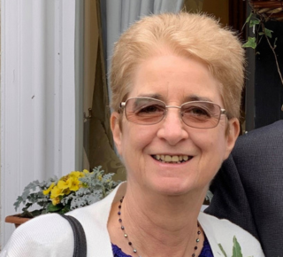
Gavin Howell,  GA Safeguarding Lead  ghowell@unitarian.org.uk | Sarah Benfield –  EC Safeguarding Trustee sarah.benfield2@btinternet.com | Simon Hall - EC Safeguarding Trustee - simon@simonhall.me.uk

